You WIL Summit 2026 Application Form

The Young Women Into Leadership (You WIL) Summit 2026, will be taking place this year from Monday 20th July to Monday 27th July 2026 (excluding weekend).
Since its inaugural launch in July 2021, You WIL has established itself as an empowering programme for future generations, embracing cultural diversity.
Led by Birmingham City Council and kindly supported by the University of Birmingham, the programme invites like-minded young women aged 14–16 from Birmingham and cities around the world to connect through a series of interactive two-hour online sessions. Working in multinational groups, participants collaborate to develop a final 10–15 minute presentation.
During the Monday to Friday programme, girls will be able to listen to presentations from inspirational female leaders from the worlds of Politics and Public Service, Business, Sport, STEM (Science, Technology, Engineering and Maths) and Culture. There will also be time for questions.
The groups will be supported by mentors from the University of Birmingham, who will work closely with participants as they develop their final presentations. To provide additional guidance, one-hour, mentor-supported group preparation sessions will take place on Tuesday 21 July and Friday 24 July, running from 2–3 pm immediately after the lunchtime programme sessions (12–2 pm). These sessions are designed to give girls extra time and support ahead of the final presentations, which will be delivered on the last day of the programme, 27 July (12–2 pm).
Please fill in ALL SECTIONS of this application form and return your completed form to European and International Affairs Team Europe.Int@birmingham.gov.uk
Submission deadline: Midnight GMT on 12th June 2026

Note: Your application must be submitted in WORD DOC or PDF format.
For any queries, please contact European and International Affairs Team at the email above.

APPLICATION PROCESS & DEADLINE (ALL 3 SECTIONS MUST BE COMPLETED AND SUBMITTED BY MIDNIGHT GMT ON 12th JUNE 2026)
- Sections 1
  - All applicants must complete Section 1 (personal information).

- Section 2
  - Applicants’ schools must provide a supportive recommendation letter from a teacher or mentor describing what qualities make the candidate a suitable applicant for the 2026 You WIL summit.

- Section 3
  - Applicants’ custodian(s) (e.g. parent/legal guardian) MUST complete Section 3.

- Section 4
  - Applicants’ custodian(s) (e.g. parent/legal guardian) MUST complete the GDPR Form.

- Candidates selected to take part in You WIL 2026 will be informed by 29th June 2026.

SELECTION PROCESS
It is the applicants’ schools/mentors who will put forward candidates to participate in You WIL. The YouWIL organising team are keen to find out more about applicants and look forward to receiving their supported applications.

PROTECTION OF MINORS
The host university, the University of Birmingham has adopted certain safeguards to protect minors participating in university programmes. For the university’s safeguarding policy please visit: safeguarding-policy.docx

It is a duty of Birmingham City Council to ensure that children/young people and adults are safeguarded from harm. For Birmingham City Council’s Safeguarding policy, please visit, Corporate Safeguarding Policy | Birmingham City Council

GDPR
We are committed to safeguarding your privacy and ensuring our compliance with the legislation. We will be transparent with you and provide accessible information about how we use your information. A GDPR form will be sent across to participants for their guardians to read and consent to.
For more information on GDPR and how Birmingham City Council processes personal data, please visit Overview | Privacy statement | Birmingham City Council
Section 1 - Applicant Information
APPLICANT’S PERSONAL INFORMATION
First Name |  |  |  |  | Last name
City |  |  |  | Region/Province |  |  | Post Code
Country |  |  |  | E-mail Address
Birthdate (dd/mm/yy)

ADDITIONAL INFORMATION
What languages do you speak? English is the language used in the programme
How did you learn about this programme?
Are you available to participate in the You WIL online summit from July 20th – July 27th 2026? |  |  | YES □ | NO □
Do you have access to a computer and internet? |  |  | YES □ | NO □

EDUCATION
Name of School currently attending
School Address
City |  |  | Region/Province |  | Post Code
Country

Statement Of School Support/ Mentor Support (School/Mentor to complete. Please also see section 3)
Full Name |  | Relationship (e.g. form tutor or subject teacher or head teacher/ principal)
Work E-mail address |  | Work Phone No.

APPLICANT’S SIGNATURE
I certify that my answer is true and complete to the best of my knowledge.
Signature |  | Print Name |  | Date

Please go to the next page for Section 2 of the application form.

Section 2 – Recommendation Letter
A recommendation letter between 250-500 words from a teacher or mentor on official letterheaded paper should be submitted on behalf of the applicant’s school. The letter should identify the qualities the applicant has shown regarding globally-minded leadership. The letter should also indicate those qualities that the candidate displays regarding their suitability for the 2026 You WIL Summit.
Letters are due by midnight GMT on 12th June 2026. Please attach to the end of this application or as a separate WORD/PDF file.
Please submit your letter via email to:
European and International Affairs Team Europe.Int@birmingham.gov.uk

RECOMMENDING TEACHER/MENTOR (member of school staff) INFORMATION
First Name |  |  |  |  |  | Last name
Name of the Student Applying to You WIL
Relationship to Applicant (e.g. form tutor or subject teacher or head teacher/ principal/mentor)
E-mail Address
Title |  |  |  |  |  |  | School/  Institution
Preferred Contact Phone No.
I certify that this information is true and complete to the best of my knowledge.
Title |  |  |  |  | Name |  |  |  | Signature
Date

Please go to the next page for Section 3 of the application form.

Section 3 – Custodian (Parent/Guardian) Information
PARENT/GUARDIAN INFORMATION
First Name |  |  |  | Last name
City |  |  |  | Region/Province |  |  | Post Code
Country |  |  |  | E-mail Address
Home Phone |  |  |  | Mobile Phone |  |  |  | Work Phone
Relationship to the applicant

2ND PARENT/GUARDIAN INFORMATION (IF REQUIRED)
First Name |  |  |  |  |  | Middle |  |  |  |  | Last
City |  |  |  | Region/Province |  |  |  |  | Post Code
Country |  |  |  |  | E-mail Address
Home Phone |  |  |  |  | Mobile Phone |  |  |  |  | Work Phone
Relationship to the applicant

PARENT/ GUARDIAN SIGNATURE
I confirm that my daughter will be aged between 14-16 years on 20t July 2026 and I give permission for my daughter to participate in the You WIL summit this year.
Signature |  | Print Name |  | Date
Signature |  | Print Name |  | Date

Section 4 – GDPR Form
Parents/guardians please use link or QR Code to complete the GDPR Form
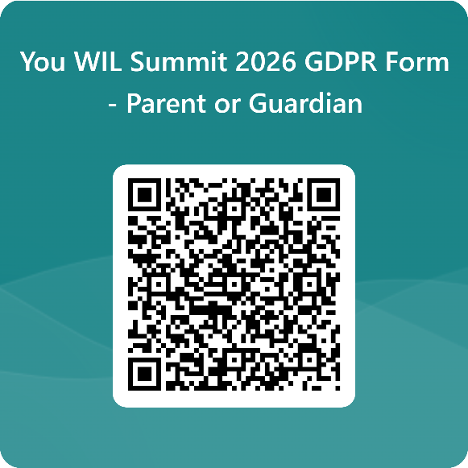
https://forms.office.com/e/scrkYPQ8RB?origin=lprLink

