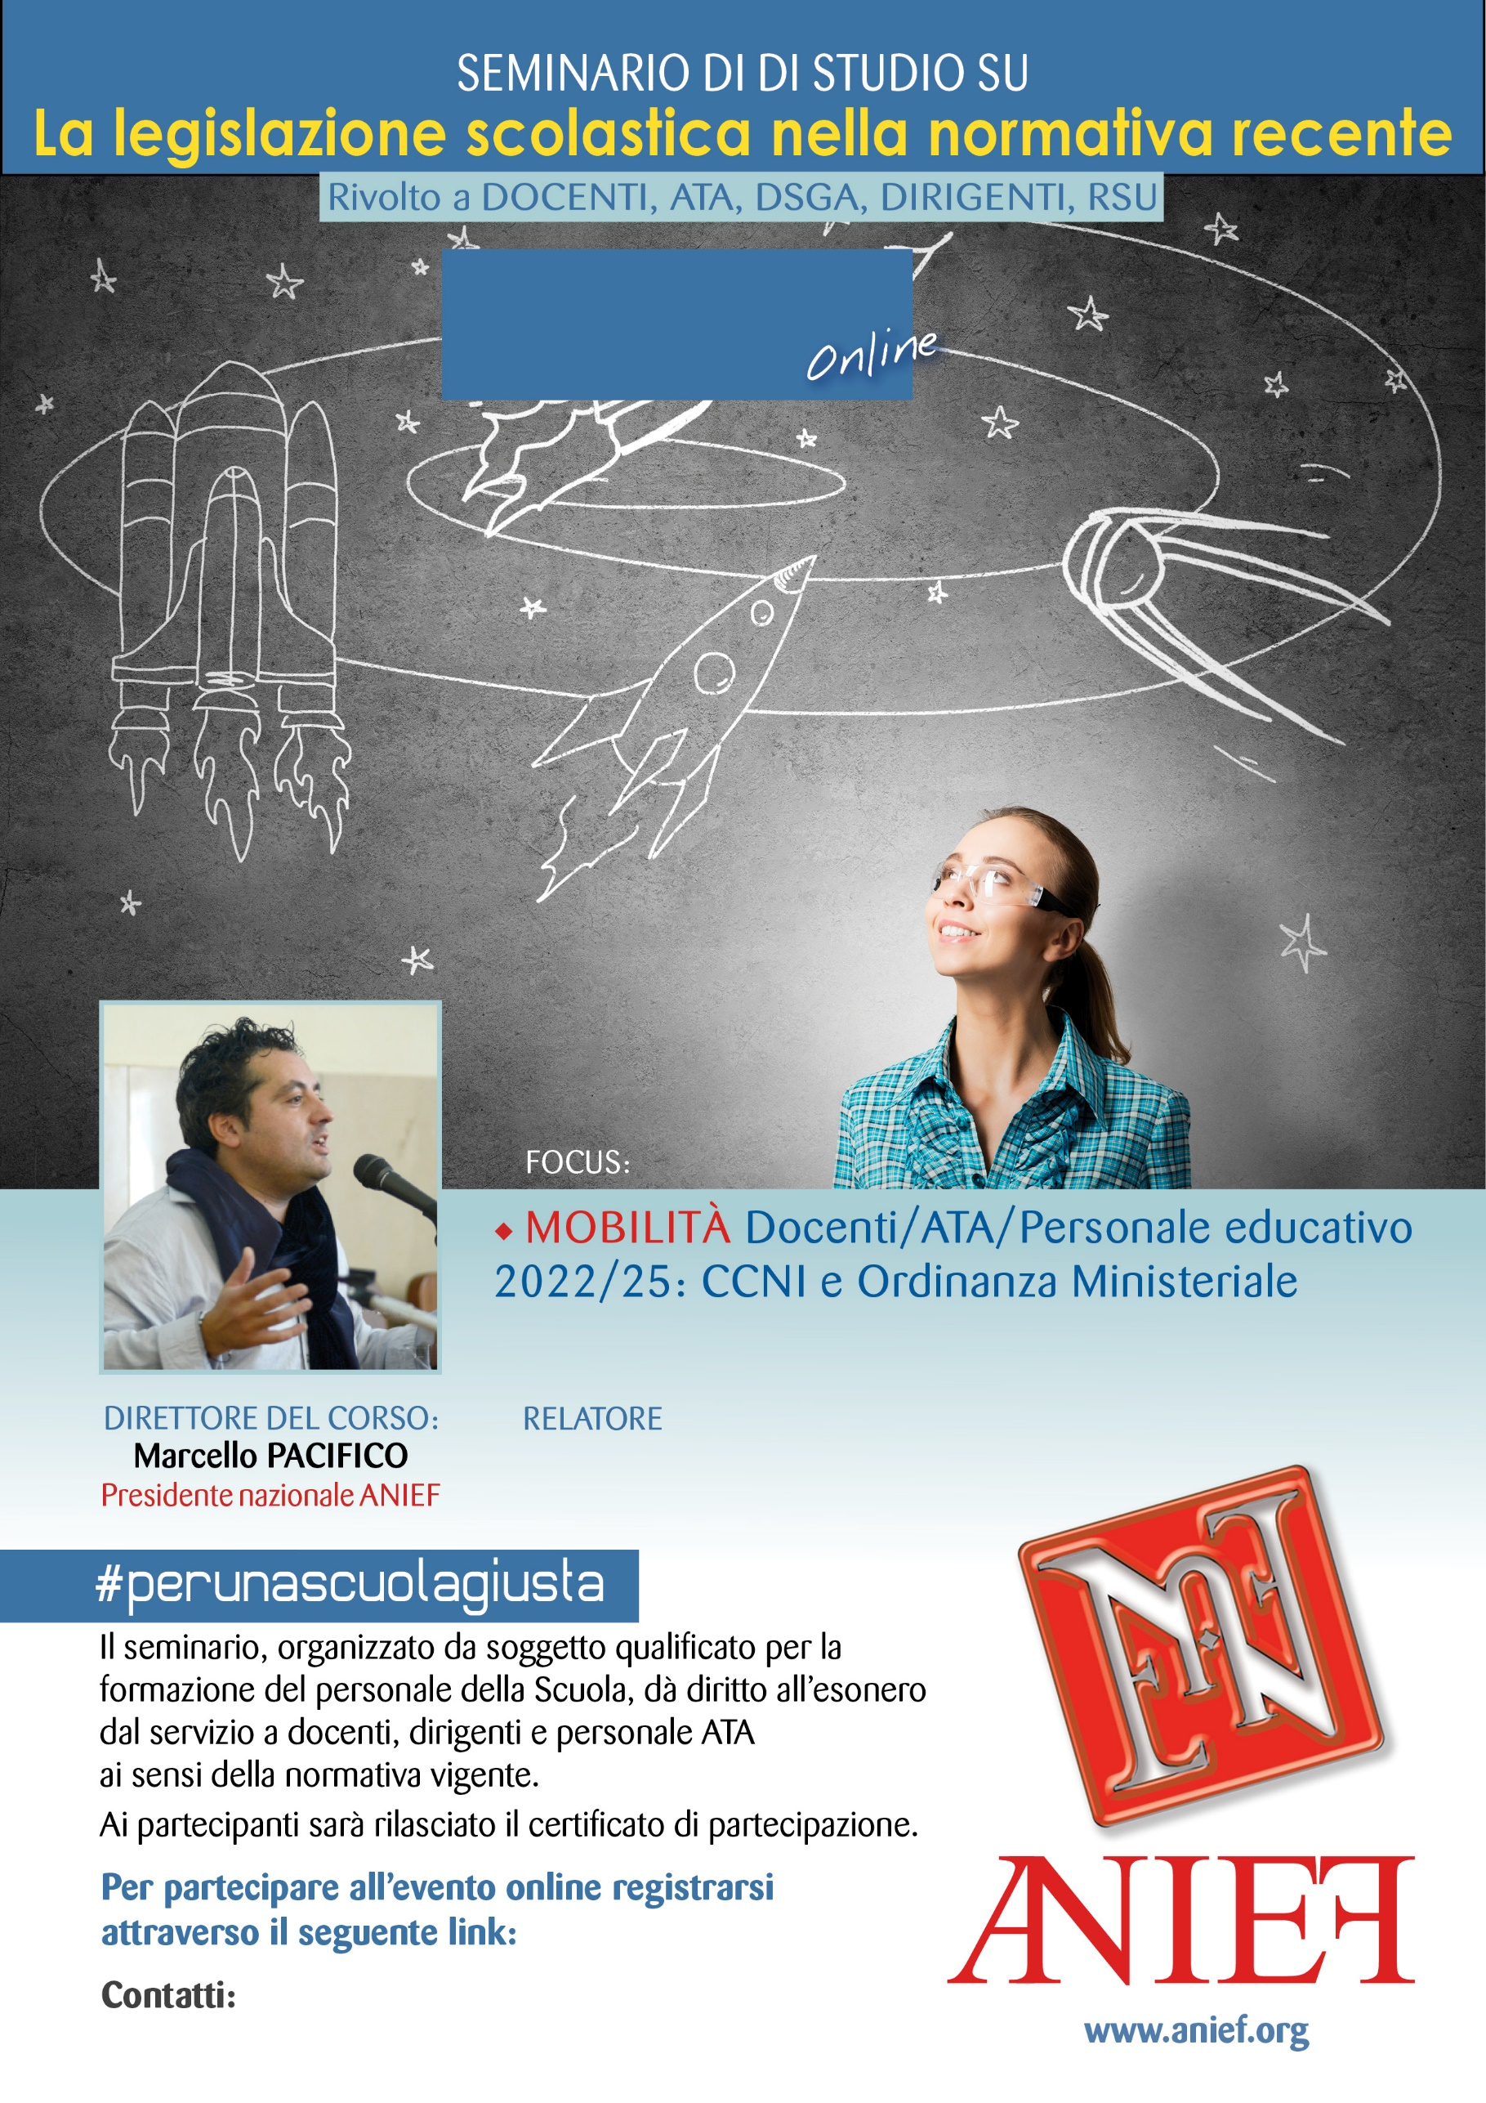

LINK DIRETTA: https://anief.org/as/131C

piemonte@anief.net

GIUSEPPE FARACI

Alessandria, Asti, Biella, Cuneo, Novara, Verbania, Vercelli

09/03/2022 ORE 10:00 – 12:00